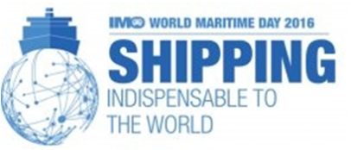

**INTERNATIONAL CONFERENCE ON**

**SHIPPING: INDISPENSABLE TO THE WORLD (IMO THEME FOR 2016)**

**19th April 2016**

**REGISTRATION FORM**

**Name**  : ……………………………………………………………………………………………

**Designation**  : ……………………………………………………………………………………………

**Affiliation** : ……………………………………………………………………………………………

………………………………………………………………………………………………

………………………………………………………………………………………………

……………………………………………………………………………………………..

**Type of Presentation** : Paper presentation /Participation only

Title of the paper, if any :………………………………………………………………………………………………………………............

………………………………………………………………………………………………………………....................................................

**Address for communication**:

…………………………………………………………………………………………….

…………………………………………………………………………………………….

…………………………………………………………………………………………….

…………………………………………………………………………………………….

…………………………………………………………………………………………….

**Mobile No.** : ……………………………………………………………………………………………

**E. Mail** : …………………………………………………………………………………………….

**Note:** Prior Registration is compulsory for participation in Conference. There is NO Registration Fee.

Last date for Registration is 15-04-2016. Registration can be done by sending this form through email.